1. MAIN SURVEY MATERIAL
1. Informed Consent
PURPOSE OF THE STUDY This is an invitation to participate in a research study. The purpose of this study is to investigate how older adults have been using online resources to get COVID-19 information during this pandemic. Understanding this could help us design better online services that better match the needs and preferences of older adults.
STUDY PROCEDURES You are being asked to complete an online survey. It should take no more than 30 minutes to complete. The survey will ask general demographic questions as well as your preferences for using online resources. We will further ask questions related to the COVID-19 pandemic and how you managed to use the online resources to seek information about the pandemic.
VOLUNTARY PARTICIPATION Participation is completely your choice. You can change your mind and stop completing the survey at any time and do not need to provide a rea- son. Withdrawing from the study will not impact your relationship with the research team in any way.
POTENTIAL RISKS There are no expected risks to you by participating in this research; however, you may find participation tiring. You can save your answers and finishing the survey at a later time if you get tired.
POTENTIAL BENEFITS There are no direct benefits to participating in this research study although your participation may help others by helping us to design and develop online resources that better match the needs and preferences of older adults.
COMPENSATION As compensation for your participation in the survey, you will receive an entry into a draw to win a gifts card, valued at $75 each. The odds of winning will be no less than 1 in 25.
CONFIDENTIALITY By default, your data will only be accessible to the research team. However, with your consent we would like to upload the online survey data to a scholarly online database (e.g., Open Science Framework). The benefit of sharing your data in this way is that it would enable other researchers to make use of the data. It also helps ensure the integrity of scientific research by enabling others to check that the analysis was done properly. However, it is entirely up to you if you would like to share your data. You may participate in this research even if you chose not to.
I consent to sharing my anonymized online survey data.
- Yes
- No
If you agree to be contacted for a follow up phone interview at the end of this online sur- vey, your identifying information (email address or phone number) will only be collected for the purpose of the voluntarily phone interview and we guarantee that it will be kept separate from the online survey data.

QUESTIONS You are free to ask questions about the process at any time. You may ask questions by contacting [ANONYMIZED].
If you have any ethical concerns or complaints about your participation in this study and want to speak with someone not on the research team, please contact the [ANONYMIZED] Ethics Manager at [ANONYMIZED] or [ANONYMIZED].
[ ] Please check here to confirm you have read the above information, that you consent to sharing your data to the research community, and that you wish to participate in this study. Agreeing to participate does not waive any of your rights or release the researchers from their responsibilities. You may print or save a copy of this page by clicking the button below.
2. Demographics and Health-Related Questions
- With which gender do you identify?
  - Male
  - Female
  - Other
  - I prefer not to answer
- How old are you?
- How many people currently reside with you?
  - 0 (I live alone)
  - 1
  - 2
  - 3
  - 4
  - 5 or more
- Please indicate their relationship to you using the box below:
  - Relationship:
- In which province and city do you currently live:
  - Province/city:
- What type of housing do you currently live in:
  - Facility (e.g., assisted living, supportive housing, long-term care)
  - Independent home (e.g., house, apartment, independent living facility)
  - Other:
- Suppose you have found an advertisement for a new tablet computer priced as 1K dollars and that you decided you like to own one. What would you be willing to do in this scenario?

  - I would go out to the store and buy it.
  - I would only be able to get it if it were gifted to me.
  - I would never want to purchase a tablet.
  - I prefer not to answer
- Please select the languages below for which you are fully confident in your ability to read and comprehend news and other text-heavy documents: (select all that apply)
  - English
  - French
  - Spanish
  - Chinese
  - Other:
- In addition to the languages selected in the last question, are there any additional languages that you regularly need to use in daily life but do not feel confident in your ability to understand: (Choose all that apply)
  - English
  - French
  - Spanish
  - Chinese
  - Other:
- What is the highest degree or level of education you have completed?
  - Less than high school
  - High school graduate
  - Some post-secondary
  - Bachelor’s Degree
  - Master’s Degree
  - Doctorate Degree
  - Other:
- What is your current employment status?
  - Full-Time
  - Part-Time
  - Retired
  - Other:
- For the following questions, please answer for difficulties or conditions that have lasted or are expected to last for six months or more (please remember that your answers will be kept strictly confidential). For these questions, choose one of the following options:

  - No
  - Sometimes
  - Often
  - Always
- Do you have any difficulty seeing or hearing? (if you use glasses, contact lenses, a hearing aid or a cochlear implant, please respond based on your ability to see or hear when using your seeing or hearing aid.)
- Do you have any difficulty walking, using stairs, using your hands or fingers, or doing other physical activities?
- Do you have any difficulty learning, remembering or concentrating?
- Do you have any emotional, psychological or mental health conditions? These may include anxiety, depression, bipolar disorder, substance abuse, anorexia, as well as other conditions.
- Do you have any other health problem or chronic long-term condition that has lasted or is expected to last for six months or more?
- How often do these health problems or conditions limit your daily activities? (If you indicated more than one health problem, please answer based on the health problem or condition that most limits your daily activities).
- Relative to your peers, how would you rate your knowledge of COVID-19 (coronavirus)?
  - No knowledge (never heard of COVID-19)
  - Poor
  - Fair
  - Adequate
  - Good
  - Excellent
3. Challenges-Related Questions
What is coronavirus?
Coronaviruses are a large family of viruses which may cause illness in animals or humans. In humans, several coronaviruses are known to cause respiratory infections ranging from the common cold to more severe diseases such as Middle East Respiratory Syndrome (MERS) and Severe Acute Respiratory Syndrome(SARS). The most recently discovered coronavirus causes coronavirus disease COVID-19.
Source: https://www.who.int/emergencies/diseases/novel-coronavirus-2019/question-and- answers-hub/q-a-detail/q-a-coronaviruses
What is COVID-19?
COVID-19 is a disease caused by a new coronavirus, which has not been previously iden- tified in humans. In most cases, COVID-19 causes mild symptoms including dry cough, tiredness and fever, though fever may not be a symptom for some older people. Other

mild symptoms include aches and pains, nasal congestion, runny nose, sore throat or diarrhea. Some people become infected but don’t develop any symptoms and don’t feel unwell. Most people recover from the disease without needing special treatment. Around 1 out of every 6 people who gets COVID-19 becomes seriously ill and has difficulty breathing.
Source: https://www.who.int/emergencies/diseases/novel-coronavirus-2019/question-and- answers-hub/q-a-detail/q-a-on-on-covid-19-for-older-people
- How much of the above text did you already know?
  - All of it
  - Some of it
  - Little of it
  - None of it
- Of the COVID-19 pandemic measures introduced in your community, which have affected you the most?
  - Closures of businesses
  - Closures of public services
  - Closure of leisure centers
  - Restrictions on social interaction
  - The virtualization of essential services (e.g., doctor’s visits by video conference or telephone)
  - The virtualization of work or school (e.g., working from home / telecommuting)
  - Reduction in available health-care services (e.g., cancellation of elective surgeries, routine check-ups, etc.)
  - I prefer not to answer
  - Other:
- To what extent have these changes affected your daily routine?
  - I have had to substantially modify my daily routines
  - I have had to change my daily routines a bit
  - My daily routines are largely the same
  - I’m not sure how much my daily routines have changed
  - I prefer not to answer
- Please describe the changes to your daily routine using the box below: (if you experienced more than one change, please describe the one a↵ecting your life the most)
  - Major daily routine change:
- Have you needed to learn any new online tools or services during the COVID-19 pandemic?

  - Yes
  - No
- If the answer is yes, which one(s) of these online tools and services you have learned during the COVID-19 pandemic? (Choose all that apply)
  - Virtual Meeting applications (e.g., Zoom, Google Hangouts, Microsoft Teams, Face Time, Facebook Messenger, WhatsApp, Skype)
  - Online shopping (e.g., Amazon, Kjiji, ebay, etc.)
  - Online banking and contactless payment (e.g., Interac e-transfer, PayPal, etc.)
  - Specialized telehealth services (e.g., https://www.bbd.ca/blog/telehealth-services- canada/ )
  - Online Entertainment (such as online museum tours, online gaming, Netflix, Youtube, etc.)
  - Online learning
  - Other:
- How did you go about learning these online tools and services during the COVID-19 pandemic? (Choose all that apply)
  - I read about using these online tools and services
  - I ask for help from family and friends
  - I seek professional help by reaching out to the services support centers
  - I learn by trying the tools and services myself
  - Other:
- For the following questions, please choose to which extent you do agree or disagree with the following statements and for every statement choose one of the following options:
  - Strongly Disagree
  - Disagree
  - Neutral
  - Agree
  - Strongly Agree
- I found the tools and services I use during COVID-19 unnecessarily complex.
- I thought the tools and services I use during COVID-19 were easy to use.
- I think that I would need the support of a technical person to be able to use these tools and services during COVID-19.
- I would imagine that most of my peers would learn to use these tools and services during COVID-19 very quickly.
- I found the tools and services I use during COVID-19 very cumbersome.
- I felt very confident using these tools and services during COVID-19.
- I needed to learn a lot of things before I could get going with these tools and services during COVID-19.

4. Online Resources-Related Questions
- How often do you consult online resources (news websites, mobile apps, social media, online search, etc.) when you want to get COVID-19 information?
  - Always
  - Most of the time
  - Half of the time
  - Sometimes
  - Never
  - I prefer not to answer
- Do you prefer to use online resources (news websites, mobile apps, social media, online search, etc.) when you want to get COVID-19 information?
  - Yes
  - No
  - I prefer not to answer
- If not, how would you prefer to get COVID-19-related information and news? (Choose one choice only)
  - Print (newspapers, magazines, books)
  - Radio (broadcast, satellite)
  - TV (broadcast, cable)
  - Friends and family
  - Other:
- For which of the topics below, do you consult online resources related to COVID-19 most frequently (Choose one choice only)
  - Potential treatments
  - Diagnosis, symptoms, and protection measures
  - Government policies including social distancing regulations
  - Statistics about new cases and deaths rates
  - Other:
- What are potential reasons why you choose to get COVID-19 related information from online sources? (Choose all that apply)
  - Lack of access to other professional information sources (e.g., doctors, libraries, government agencies)
  - Convenience (easy, fast) of online resources
  - Reliability of online resources
  - Lack of access to personal information sources (e.g., friends, family)
  - Other:

- Of the online resources you consult, which do you use most frequently to get COVID-19 related information? (Choose one choice only)
  - News and government websites
  - Partisan sites
  - Forums and blogs
  - Social Media (Facebook, Twitter, Instagram, Youtube, LinkedIn, Reddit, etc.)
  - Online Search (Google, Bing, Yahoo etc.)
  - Online newspapers, journals and academic articles
  - Other:
- How much do you trust the accuracy of information about covid-19 pandemic from: A great deal, A lot, A moderate amount, A little, None at all, Not applicable
  - News and government websites
  - Partisan sites
  - Forums and blogs
  - Social Media (Facebook, Twitter, Instagram, Youtube, LinkedIn, Reddit, etc.)
  - Online Search (Google, Bing, Yahoo etc.)
  - Online newspapers, journals and academic articles
  - Other:
5. Exposure to the coronavirus misinformation Questions
- Here is a list of eight statements about the novel COVID-19 pandemic, indicate what you know about each sentence bellow:
  - The COVID-19 virus was stolen out of a Canadian lab by Chinese spies.
  - While COVID-19 is spreading rapidly, most people will experience only mild or moderate symptoms.
  - ......
  - ......
  - ......
  - ......
  - ......
For each of the above sentences, please choose one of the following options:
  - I have heard about this before and I believe it is true
  - I have heard about this before and I believe it is false
  - I have heard about this before and I am uncertain whether it is true or false
  - I have never heard about this before
- Which actions do you take to verify online information about COVID-19? Please choose one of the following options for each statement:

- Yes
- No
  - I consult family and friends.
  - I only visit sources I already trust.
  - I consult multiple sites and decide based on what the majority say.
  - I only trust websites ranked highly in the search results.
  - I only trust high quality websites.
  - What does this mean – professional looking? Quality information? etc.
- Do you often check the veracity/correctness of COVID-19 information you en- counter online or do you mostly trust the information you find online to be ac- curate?
- Yes, I check the veracity of COVID-19 information online.
- No, I trust the information I find online to be accurate.
- I prefer not to answer.
- How often do you encounter what you perceive as misinformation about COVID-19 online?
- Daily
- Weekly
- Monthly
- Less than once a month
- Never
- I prefer not to answer
- Once you decide a particular piece of information about COVID-19 is misinformation, what do you usually do? (Choose one choice only)
- Consult other sources
- Limit the usage of specific online platforms
- Report the source of misinformation to the system or platform (e.g., via Face- book’s Report Post)
- Ignore the information
- Other:
6. Social Media Platform New Features Questions
In response to the pandemic, several online platforms have introduced new features to combat misinformation online. The next sequence of questions asks how familiar you are with these features.


Figure S1.1: Twitter’s initiative to combat misinformation: Linking explicitly to trusted sources when users search for ‘COVID’ on the platform

- Twitter: linking explicitly to trusted sources when someone searches for “Covid” on the platform.
  - How much do you know about this Twitter initiative?
    - Never heard of this
    - Heard of it but I do not use it
    - I use it sometimes
    - I use it all the time
  - How do you feel about Twitter’s approach of using ”Know The Facts” search prompt to combat COVID-19 misinformation? (Choose all that apply)
    - I find it helpful in searching for correct information
    - It makes me feel that most of the content in the platform is misinformation
    - It makes me believe that what is not flagged as misinformation is always true
    - It makes me question the fact that was checked
    - I disagree with what fact-checkers state most of the time
    - I am not sure
    - Other:
- Facebook: labeling known misinformation using fact checkers.


Figure S1.2: Facebook (Meta)’s initiative to combat misinformation: labeling known misinformation using fact checkers

  - How much do you know about this Facebook initiative?
    - Never heard of this
    - Heard of it but I do not use it
    - I use it sometimes
    - I use it all the time
  - How do you feel about Facebook’s approach of using fact-checkers to combat COVID-19 misinformation? (Choose all that apply)
    - I find it helpful in searching for correct information
    - It makes me feel that most of the content in the platform is misinformation
    - It makes me believe that what is not flagged as misinformation is always true
    - It makes me question the fact that was checked
    - I disagree with what fact-checkers state most of the time
    - I am not sure
    - Other:
- Google: when people search for information about the coronavirus, it will pull up a special notice with updates from the WHO.

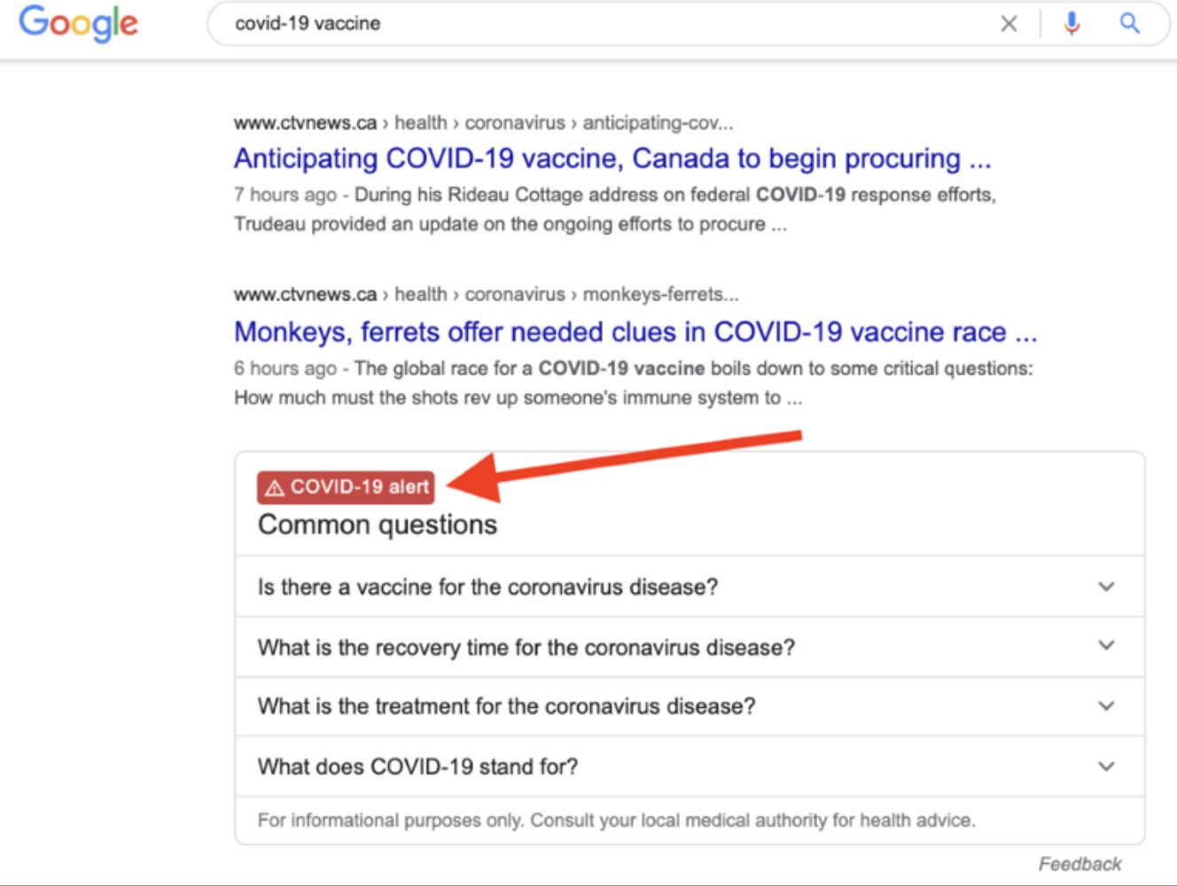
Figure S1.3: Google’s initiative to combat misinformation: when people search for information about the coronavirus, it will pull up a special notice with updates from the WHO

  - How much do you know about this Google initiative?
    - Never heard of this
    - Heard of it but I do not use it
    - I use it sometimes
    - I use it all the time
  - How do you feel about Twitter’s approach of using ”COVID-19 alert” prompt to combat COVID-19 misinformation? (Choose all that apply)
    - I find it helpful in searching for correct information
    - It makes me feel that most of the content in the platform is misinformation
    - It makes me believe that what is not flagged as misinformation is always true
    - It makes me question the fact that was checked
    - I disagree with what fact-checkers state most of the time
    - I am not sure
    - Other:
- YouTube: when you search for COVID-19, the platform highlights content from authoritative sources, and provides additional context from high-quality sources (such as CBC News etc.)
  - How much do you know about this YouTube initiative?
    - Never heard of this
    - Heard of it but I do not use it
    - I use it sometimes
    - I use it all the time
  - How do you feel about YouTube’s approach to combat COVID-19 misinformation? (Choose all that apply)
    - I find it helpful in searching for correct information

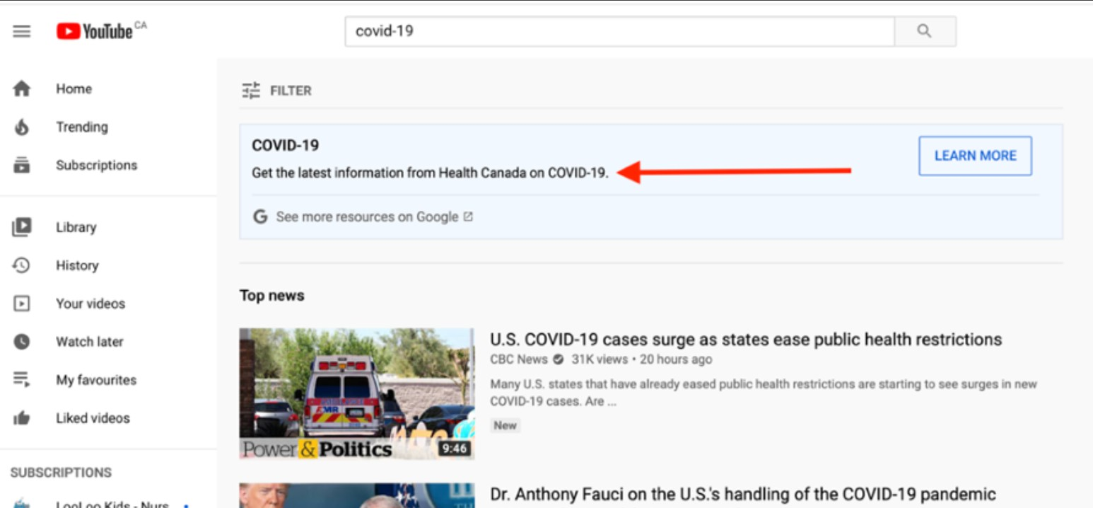
Figure S1.4: Youtube’s initiative to combat misinformation: when you search for COVID-19, the plat- form highlights content from authoritative sources, and provides additional context from high-quality sources (such as CBC News etc.)

    - It makes me feel that most of the content in the platform is misinformation
    - It makes me believe that what is not flagged as misinformation is always true
    - It makes me question the fact that was checked
    - I disagree with what fact-checkers state most of the time
    - I am not sure
    - Other:

7. Debrief
Here is a full list of statements we asked about during the study with their correct credibility judgments from reliable sources.

List of incorrect statements:
- The COVID-19 virus was stolen out of a Canadian lab by Chinese spies.
- The COVID-19 virus contains HIV-like insertions,’ suggesting it was engineered.
- The COVID-19 pandemic was predicted in a simulation.
- A group funded by Bill Gates patented the COVID-19 virus.
- The COVID-19 virus is a manmade bioweapon.
- 5G cell phone technology is linked to the coronavirus outbreak.
- Colloidal silver can cure COVID-19.
- Miracle Mineral Solution can cure COVID-19.
- Garlic can cure COVID-19.
- High doses of vitamin C have been proven to be an e↵ective treatment for COVID- 19.
- Lemon and hot water can cure COVID-19.
- The Italian Government is preventing migrants from being tested for COVID-19.
- Bill Gates plans to use COVID-19 to implement a mandatory vaccine program with microchips to surveil people.

List of correct statements:
- While COVID-19 is spreading rapidly, most people will experience only mild or moderate symptoms.
- There have been relatively few COVID-19 infections among children.
- The vast majority of people who have contracted the new coronavirus to date have recovered or are recovering.
- COVID-19 is often more severe in people 60+ yrs or with health conditions like lung or heart disease, diabetes or conditions that affect their immune system.
- COVID-19 virus can be transmitted in areas with hot and humid climates
- COVID-19 appears to spread primarily from person to person, rather than via food.
- Hand dryers are not effective in killing the new coronavirus.
- Smoking puts people at higher risk for a severe case of the COVID-19 virus
- COVID-19 can spread if you touch contaminated objects and surfaces
- The prolonged use of medical masks does not cause CO2 intoxication or oxygen deficiency
- The risk to Canadians catching the COVID-19 is considered high
- COVID-19 can spread if you touch contaminated objects and surfaces.
- There are existing evidences suggesting that COVID-19 originally came from an animal

Sources:
- https://www.who.int/westernpacific/news/multimedia/infographics/covid-19
- https://www.canada.ca/en/public-health/services/diseases/2019-novel-coronavirus- html?&utm_campaign=gc-hc-sc-coronavirus2021-ao-2021-0005-9834796012&utm_ medium=search&utm_source=google_grant-ads-107802327544&utm_content=text-en-43460 utm_term=covid-19
- https://www.who.int/westernpacific/emergencies/covid-19/information/mythbusters

2. Daily routine changes open-question Frequency Count

Table S2.1: List of most frequently mentioned words when asked in an open-ended question about the daily routine changes during COVID-19

Word | Frequency | Word | Frequency | Word | Frequency
go | 44 | much | 6 | closed | 4
friends | 35 | visiting | 6 | etc | 4
home | 33 | order | 6 | covid19 | 3
family | 26 | daily | 6 | distancing | 3
able | 22 | use | 6 | plan | 3
longer | 20 | children | 6 | seeing | 3
visit | 18 | gym | 5 | nothing | 3
time | 17 | mask | 5 | friend | 3
shopping | 16 | doctor | 5 | others | 3
get | 15 | m | 5 | spend | 3
week | 14 | church | 5 | trips | 3
see | 14 | change | 5 | masks | 3
social | 13 | grocery | 5 | normally | 3
less | 11 | little | 5 | must | 3
walk | 10 | times | 5 | working | 3
would | 10 | like | 5 | grand | 3
often | 10 | one | 5 | wear | 3
also | 9 | volunteer | 5 | restaurants | 3
used | 9 | days | 5 | energy | 3
people | 9 | every | 4 | loss | 3
stores | 9 | day | 4 | food | 3
work | 9 | lunch | 4 | due | 3
interaction | 8 | je | 4 | contact | 3
shop | 8 | co↵ee | 4 | curbside | 3
stay | 8 | need | 4 | pickup | 3
going | 8 | together | 4 | part | 3
outside | 8 | groceries | 4 | 5 | 3
activities | 7 | getting | 4 | month | 3
covid | 7 | take | 4 | place | 3
travel | 7 | mostly | 4 | visits | 3
changes | 7 | daughter | 4 | staying | 3
zoom | 7 | socialize | 4 | stopped | 3
meet | 7 | things | 4 | husband | 3
unable | 7 | physical | 4 | limit | 3
cannot | 7 | online | 4 | trip | 3
places | 7 | routine | 4 | store | 3
restaurant | 6 | find | 4 | cancelled | 3
none | 6 | house | 4 | 2 | 3
life | 6 | instead | 4 | many | 3
grandchildren | 6 | phone | 4 | person | 3

3. Mapping Research Questions to Empirical Findings

Table S3.1: Empirical Findings Mapped to Research Questions

Research Question Key Empirical Findings

RQ1: Challenges in
Seeking Information 1. 58.7% reported social interaction restrictions as the most im-
pactful challenge.
- 80% did not need new tools, suggesting high pre-existing digital literacy.
- The SUS usability score was approximately 66.27.

RQ2: Use and Trust
of Online Resources 1. Convenience (73%) and reliability (21%) drove use.
- Case statistics (40%) and policy updates (35%) were top topics.
- News and government websites were most trusted and used (61%).
- Low trust in partisan/social media; academic sources were used by less than 1%.

RQ3: Exposure to and Discernment of Misinformation
- Mean correctness: 0.458; mean discernment: 0.553.
- Accuracy improved with frequent online use (x² = 9.413,p < 0.01), usability (x² = 4.228,p < 0.05), and knowledge (x² = 13.702,p < 0.001).
- Participants had a higher discernment score than correctness, indicating sensitivity to true statements.

RQ4: Verification, Response, and Plat- form Tools
- 87% verified information using trusted sources.
- 41% relied on top-ranked search results; 39% checked multiple sites.
- 55% ignored misinformation; 21% reported trusting all online info.
- Awareness and use of platform-based mitigation tools was low

